H.T No
Regulations:
A20

Sreenidhi Institute of Science and Technology
(An Autonomous Institution)
Code No: 8B411 Date: 08-Mar-2023 (FN)

B.Tech II-Year II- Semester External Examination, February/March-2023 (Supplementary)
FLUID MECHANICS AND HYDRAULIC MACHINERY (ME)

Time: 3 Hours Max.Marks:70

Note: a) No additional answer sheets will be provided.
b) All sub-parts of a question must be answered at one place only, otherwise it will not be valued.
c) Missing data can be assumed suitably.
Bloom's Cognitive Levels of Learning (BCLL)

Remember | L1 | Apply | L3 | Evaluate | L5
Understand | L2 | Analyze | L4 | Create | L6

Part - A Max.Marks:20

Answer all QUESTIONS.

 |  | BCLL | CO(s) | Marks
1 | Explain vapor pressure and their influence on fluid flow. | L2 | CO1 | [2M]
2 | Distinguish between rotational and irrotational flow. | L3 | CO2 | [2M]
3 | Explain the Energy thickness. | L2 | CO3 | [2M]
4 | What is Dynamic similarity? | L1 | CO4 | [2M]
5 | Differentiate between the turbines and pumps. | L3 | CO5 | [2M]
6 | What are the conditions are to attain negative slip for the reciprocating pump? | L2 | CO6 | [2M]
7 | What are the assumptions under Bernoulli equation? | L2 | CO2 | [2M]
8 | What is meant by boundary layer? Why does it increase with distance from upstream edge? | L2 | CO3 | [2M]
9 | Define cavitation. | L1 | CO5 | [2M]
10 | What is a draft tube? What are its functions? | L2 | CO6 | [2M]

Part – B Max.Marks:50
ANSWER ANY FIVE QUESTIONS. EACH QUESTION CARRIES 10 MARKS.

 |  |  | BCLL | CO(s) | Marks
11. | a) | Find the pressure at point 'A'.  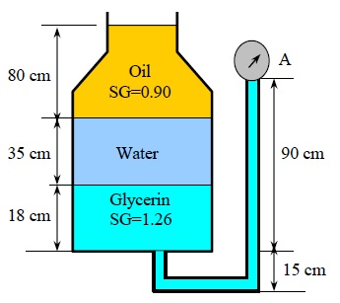 | L5 | CO1 | [5M]
 | b) | Calculate the dynamic viscosity of an oil, which is used is used for lubrication between a square plate of size 0.8 m x 0.8 m and an inclined plane with angle of inclination 30⁰ as shown in figure. The weight of the square plate is 300N and it slides down the inclined plane with a uniform velocity of 0.3 m/s. The thickness of oil film is 1.5mm.  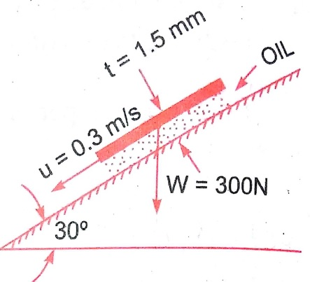 | L4 | CO1 | [5M]
12. | a) | State different types of fluid flows? | L1 | CO2 | [5M]
 | b) | The following cases represents the two velocity components. Determine the third component of velocity such that they satisfy the continuity equation.  i) u = x² + y²+ z²; v= xy² - yz² + xy  ii) v = 2y² ; w = 2xyz | L4 | CO2 | [5M]
13. | a) | Find the head loss due to friction in a pipe of diameter 300mm and length 50m, through which water is flowing at a velocity of 3 m/s using Darcy formula. | L5 | CO3 | [5M]
 | b) | The velocity profile for laminar boundary layer flows given as . Find an expression for boundary layer thickness (δ), shear stress and coefficient of drag in terms of Reynolds number. | L4 | CO3 | [5M]
14. |  | State Buckingham's π theorem. Explain the Buckingham’s π theorem for dimensional analysis with example. | L3 | CO4 | [10M]
15. | a) | Explain the working of single stage centrifugal pump with neat sketch. | L2 | CO5 | [5M]
 | b) | A single acting reciprocating pump has the plunger diameter of 20 cm and stroke of 30 cm. The pump discharges 0.53 m³ of water per minute at 60rpm. Find the theoretical discharge, co-efficient of discharge and percentage slip of the pump. Further, if suction and delivery heads are 4m and 12m respectively, work out for the power required to run the pump. | L5 | CO5 | [5M]
16. | a) | A pelton wheel is required to develop 6 MW when working under a head of 300 m. It rotates with a speed of 550 rpm. Assuming jet ratio as 10 and overall efficiency as 85%, calculate i) diameter of the wheel  ii) quantity of water required  iii) number of jets. Assume for the velocity coefficient as 0.98 and the speed ratio as 0.46. | L5 | CO6 | [5M]
 | b) | Differentiate between impulse and reaction turbine. | L3 | CO6 | [5M]
17. | a) | How vacuum pressure is measured? | L1 | CO1 | [4M]
 | b) | Distinguish between compressible and incompressible flow. | L3 | CO2 | [3M]
 | c) | Explain the term co efficient of friction. On what factors does this coefficient depend? | L2 | CO3 | [3M]
18. | a) | Define the terms dimensional analysis and model analysis. | L1 | CO4 | [4M]
 | b) | Write a short note on water hammer. | L1 | CO5 | [3M]
 | c) | Define the term Governing of a turbine. Describe the working of oil pressure governor. | L3 | CO6 | [3M]

-- 00 -- 00 –

